Robot Design Executive Summary: 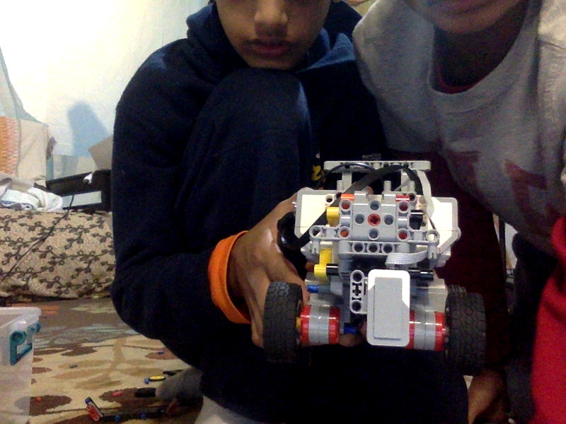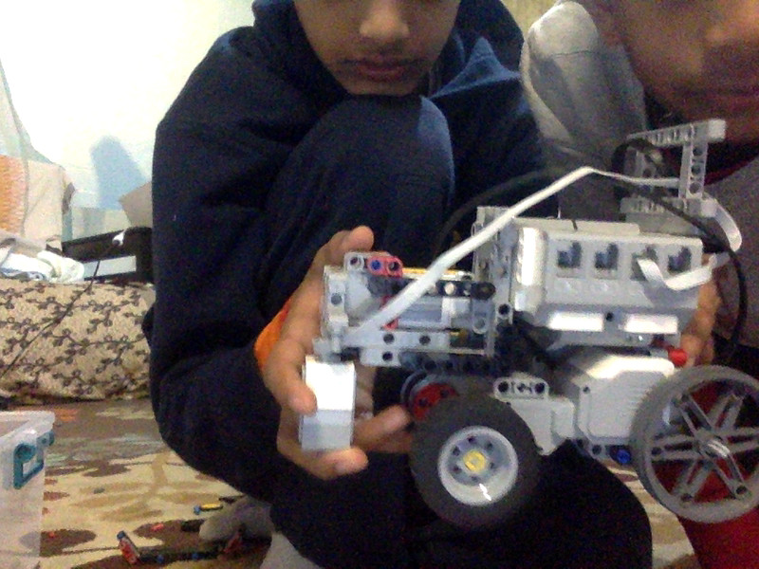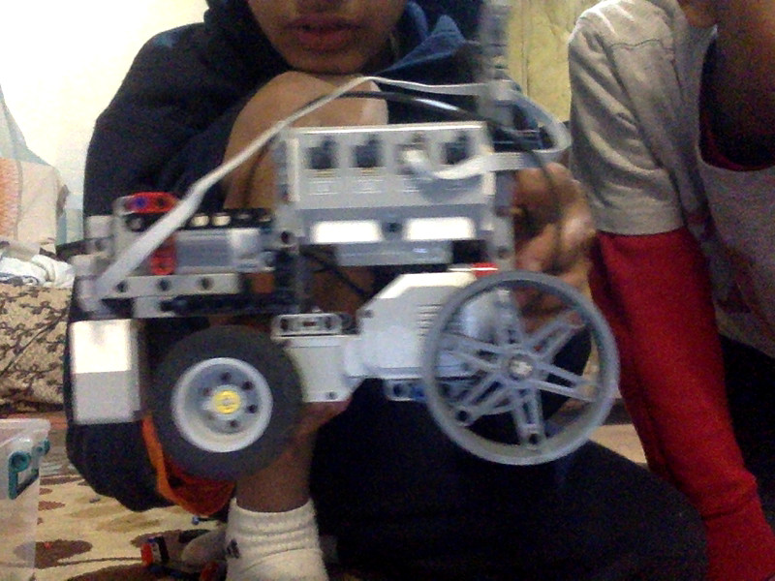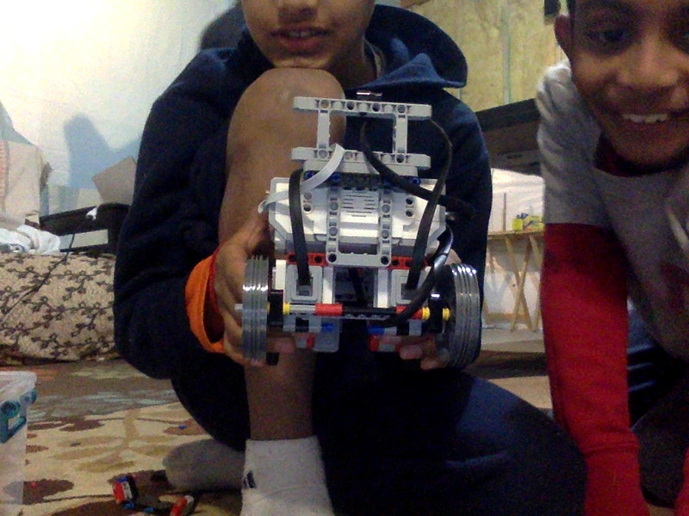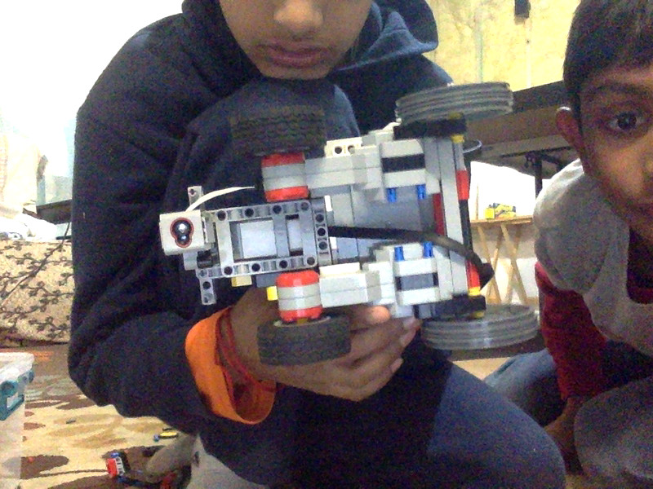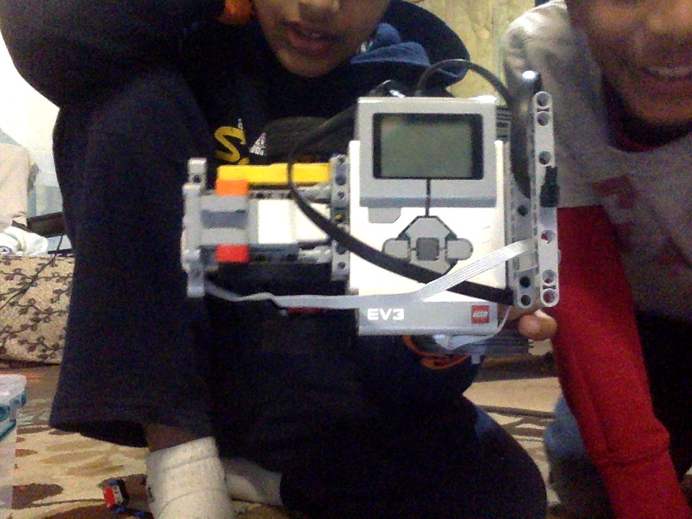
This is the REAR END of our robot
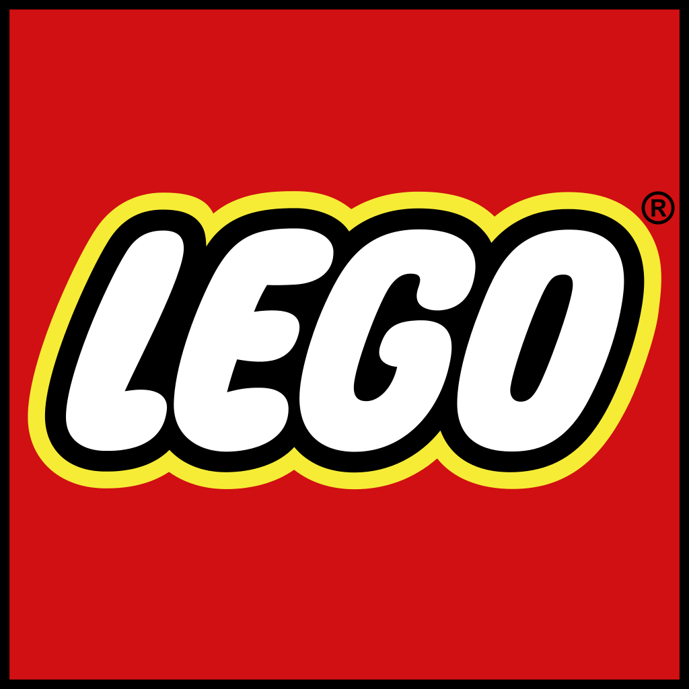
Fun:
We had a lot of fun doing robotics. We had fun synergizing with each other. Most importantly no one was left out. We cooperated to do the missions and the dissection project. We all worked together and everyone had a job, so no one was left out. A part that we all liked is that we were with each other.

Robot Facts:
Our plan was to finish the easy missions that did not have a complex design. To build it faster we used a rectangular design instead of a box design. We used 3 motors, two large motors and one medium motor. Then we used one sensor the color sensor. The color sensor helped us with many programs. We had seven programs.

Strategy:
Our strategy was to go for the main missions like shark shipment, service dog, milking automation, and feeding , which gave us a lot of points , rather than going for extra missions that did not give us as much points. As the missions became more difficult, we modified our robot which made it more complex.

Design Process:
Our team had multiple robots for examples. We all worked together as a team to make the robot. Our coach gave us a robot design blueprint what had to follow 4 principles. We used those principles and made our robot
- Compact
- Structurally solid
- Modular attachments
- Easy to alter/run
On our previous design when we just started we looked and worked together to see what is wrong with our robot design. Our software requirements were
- Recognize robot & Sensor limitations
- Accomplish missions
- Easy to debug (modify)
- Easy to show progress

Innovation:
We think our feeding attachment is good and sturdy because we used a gear system. The gear system worked out very well. We made claws that went back and forth to get the food outside of the fridge. We even had a area to keep the food in. We used a different attachment what is a slide to give the food to the gorilla, frog, and bat.

